Technical task for the traineeship candidates
QA Automation

- Make up an algorithm
- If the entered number is greater than 7, then print “Hello”
- If the entered name matches “John”, then output “Hello, John”, if not, then output "There is no such name"
- There is a numeric array at the input, it is necessary to output array elements that are multiples of 3
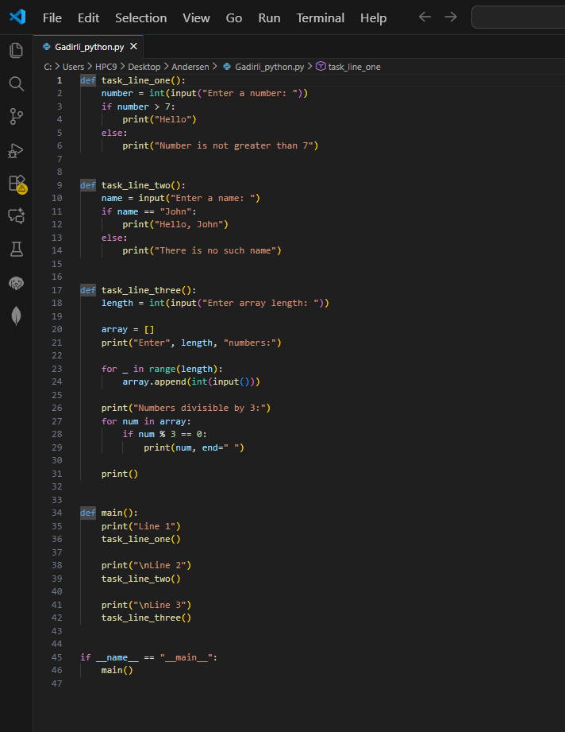
Unfortunately, Visual Studio Code encountered technical issues on my device, so I was unable to run the program locally. However, I completed the task using an online compiler.
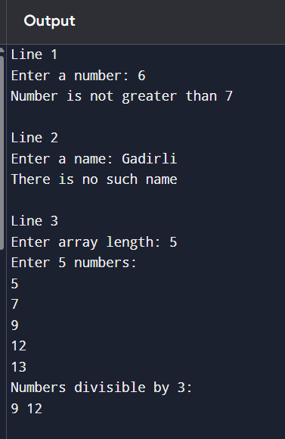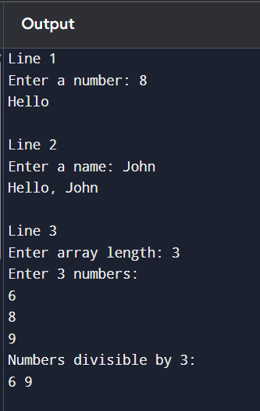

- Answer the questions
Given bracket sequence: [((())()(())]]
- Can this sequence be considered correct?
- If the answer to the previous question is “no”, then what needs to be changed in it to make it correct?

No, it is not a correct bracket sequence. Because there are two closing ] but only one opening [.
[((())()(()))] Correct version

